**Blog Capstone Project Part 1 - Templating**

1. Head over to the course resources and download the starting files for this project.

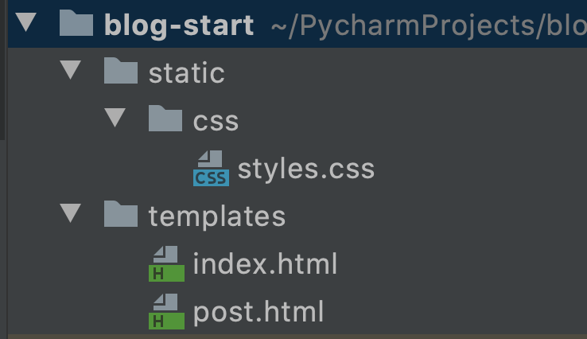

2.  Run the **main.py** file and you should see the following styling and website rendered:

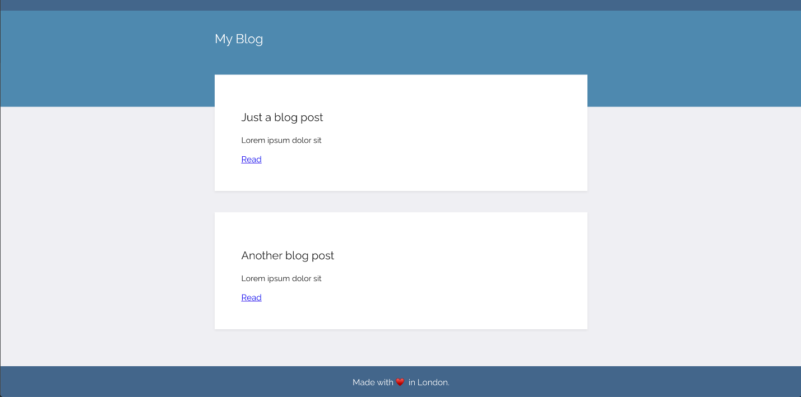

3. Using the API for our [blog posts we created on n:Point](https://www.npoint.io/docs/5abcca6f4e39b4955965), render all the blogs' title and subtitles on the home page. e.g

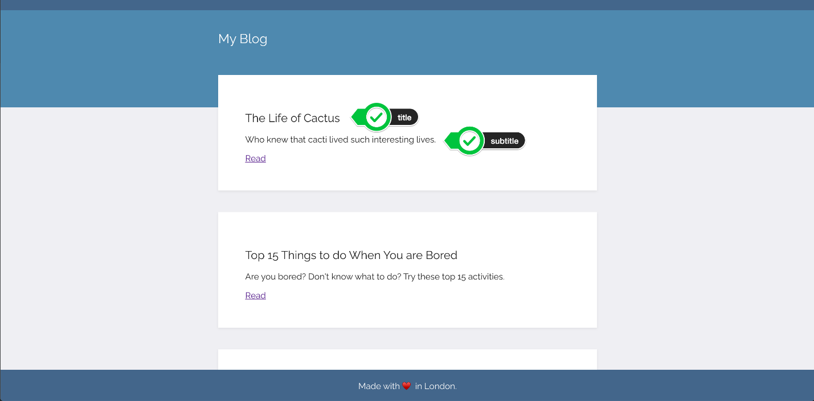

4. Make a "**Read**" anchor tag at the end of each blog post preview link to a page with the entire blog - title, subtitle and body. The individual blog posts should live at the path: URL/post/blog_id

e.g.



[SOLUTION](https://gist.github.com/TheMuellenator/7c6a08a3df3b94a28d1a867628481910)

Resources for this lecture